**1. Create a VPC**

* **Step 1**: Log in to the AWS Management Console and go to the VPC Dashboard.
* **Step 2**: Click on **Create VPC**.

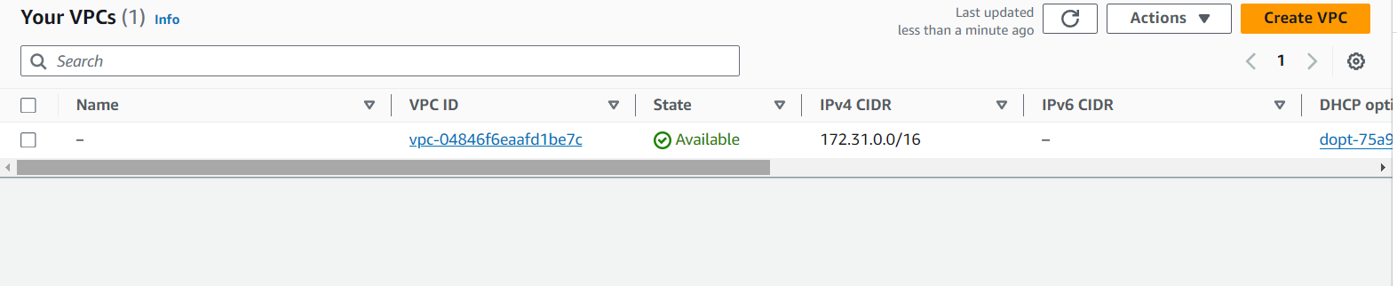

* **Step 3**: Choose **VPC only**.
* **Step 4**: Enter the following details:
  + **Name tag**: (e.g., MyVPC)
  + **IPv4 CIDR block**: 120.0.0.0/16

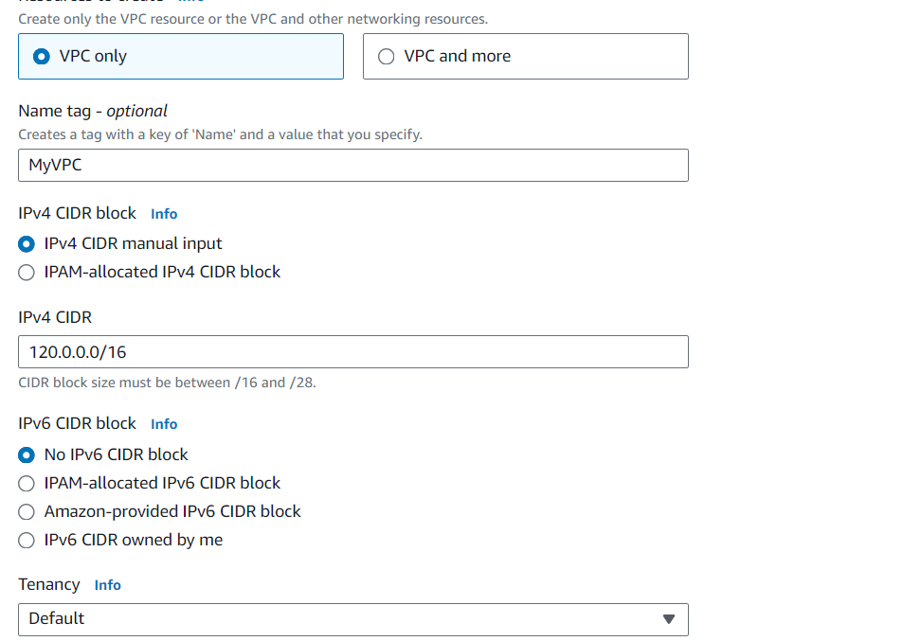

* **Step 5**: Click **Create VPC**.

**2. Create Subnets**

* **Step 1**: In the VPC Dashboard, click on **Subnets** in the left navigation pane, then click **Create Subnet**.
* **Step 2**: Select the VPC you just created.

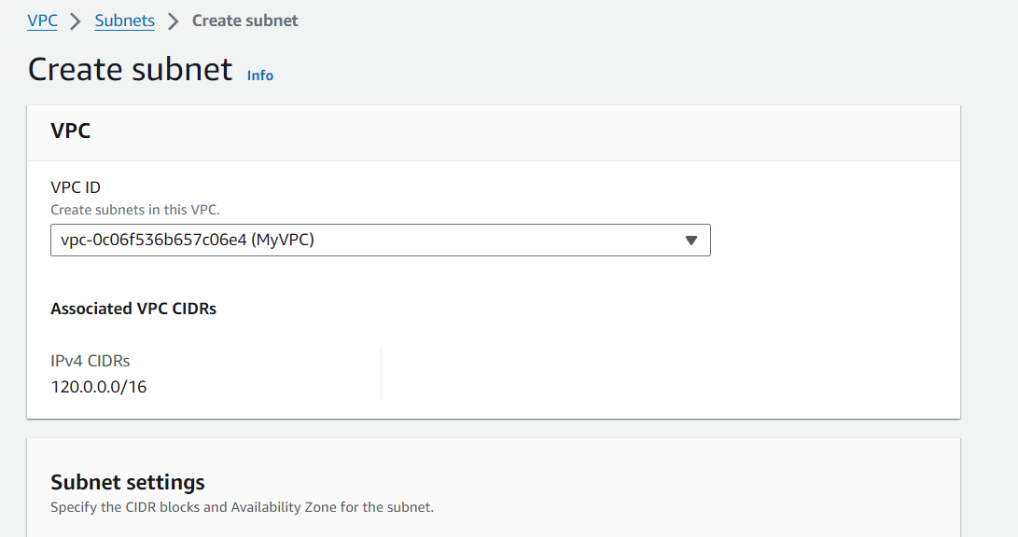

* **Step 3**: Create the public and private subnets:

**Public Subnet**

* + **Name tag**: (e.g., PublicSubnet)
  + **Availability Zone**: Choose one (e.g., us-east-1a).
  + **IPv4 CIDR block**: (e.g., 120.0.1.0/24)
  + **Step 4**: Click **Create Subnet**.

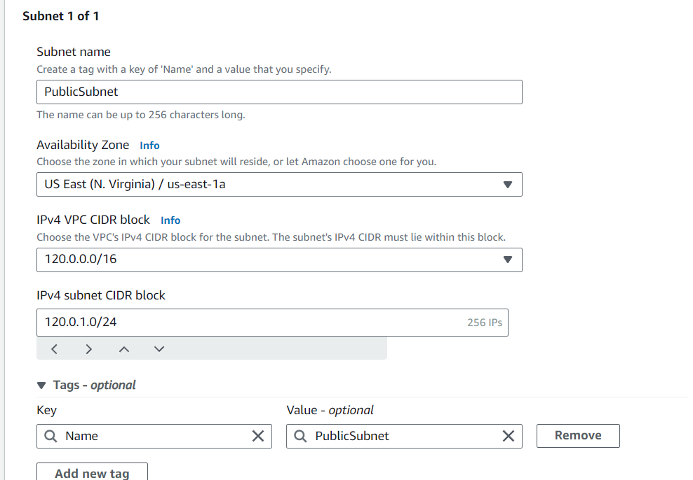

**Private Subnet 1**

* + **Name tag**: (e.g., PrivateSubnet1)
  + **Availability Zone**: Choose another one (e.g., us-east-1b).
  + **IPv4 CIDR block**: (e.g., 120.0.2.0/24)
  + **Step 4**: Click **Create Subnet**.

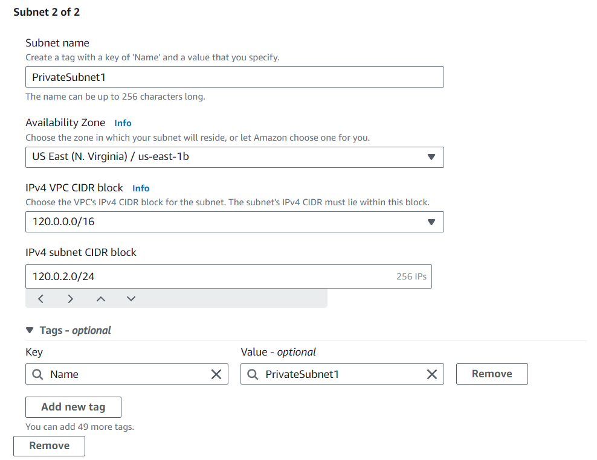

**Private Subnet 2**

* + **Name tag**: (e.g., PrivateSubnet2)
  + **Availability Zone**: Choose the third (e.g., us-east-1c).
  + **IPv4 CIDR block**: (e.g., 120.0.3.0/24)

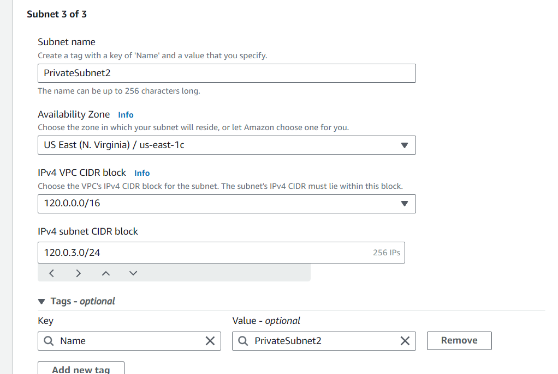

* + **Step 4**: Click **Create Subnet**.

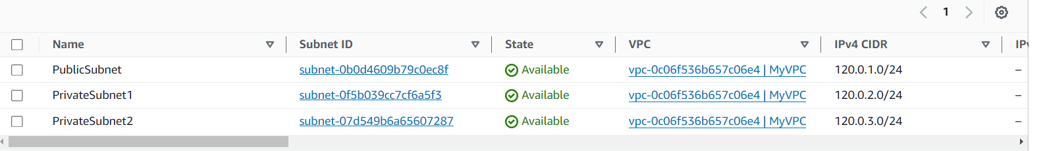

**3. Create an Internet Gateway and Attach it to the VPC**

* **Step 1**: In the VPC Dashboard, click on **Internet Gateways** in the left navigation pane, then click **Create internet gateway**.
* **Step 2**: Enter a name tag (e.g., MyInternetGateway), then click **Create internet gateway**.

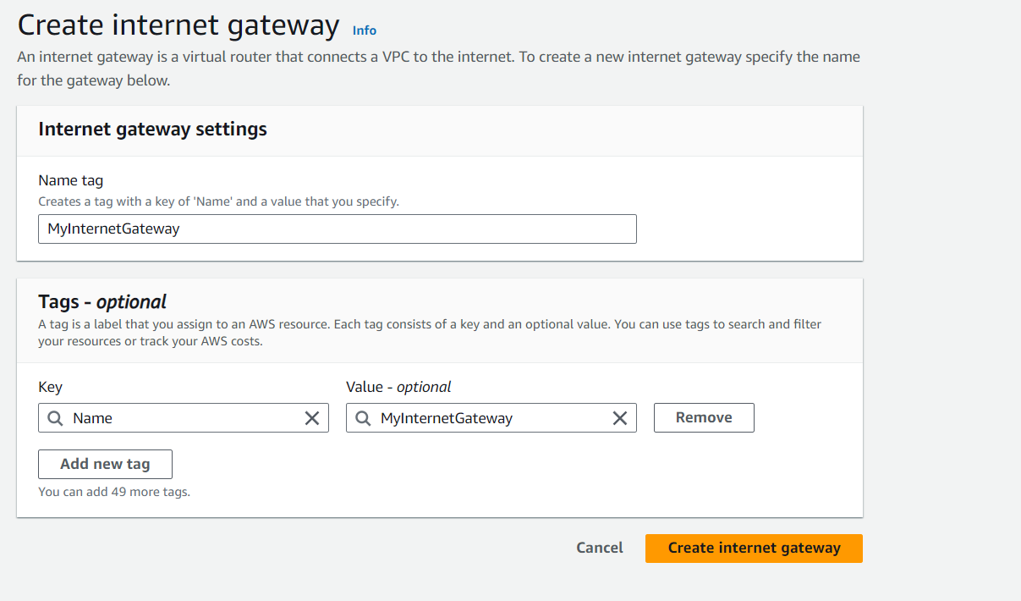

* **Step 3**: Click **Attach to VPC**, select the VPC you created, and click **Attach internet gateway**.

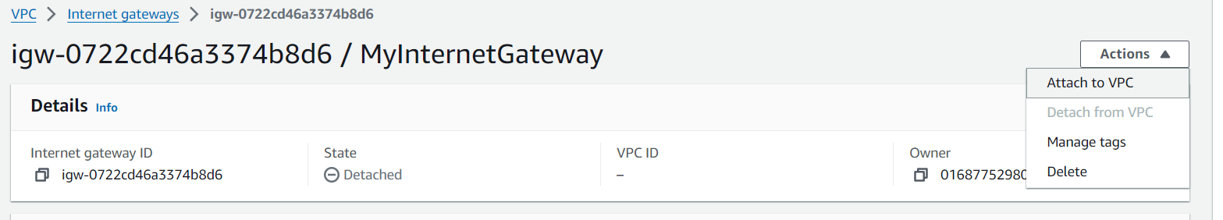

**4. Create a Route Table for the Public Subnet**

* **Step 1**: In the VPC Dashboard, click on **Route Tables** in the left navigation pane, then click **Create route table**.

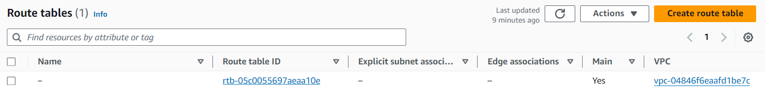

* **Step 2**: Select the VPC you created, and enter a name tag (e.g., PublicRouteTable).

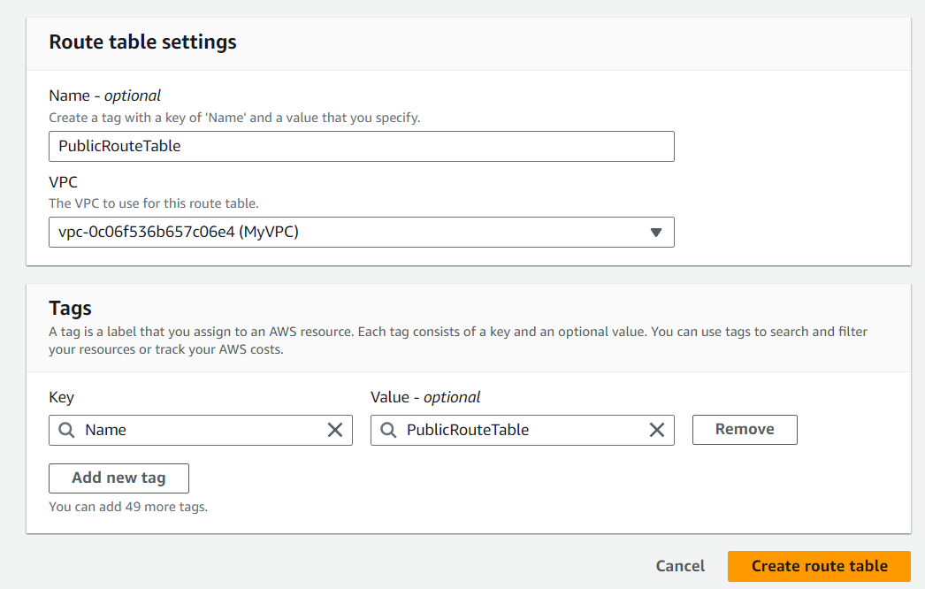

* **Step 3**: Click **Create route table**.
* **Step 4**: Select the newly created route table, and under the **Routes** tab, click **Edit routes**.
* **Step 5**: Click **Add route**:
  + **Destination**: 0.0.0.0/0
  + **Target**: Select your Internet Gateway.
* **Step 6**: Click **Save changes**.

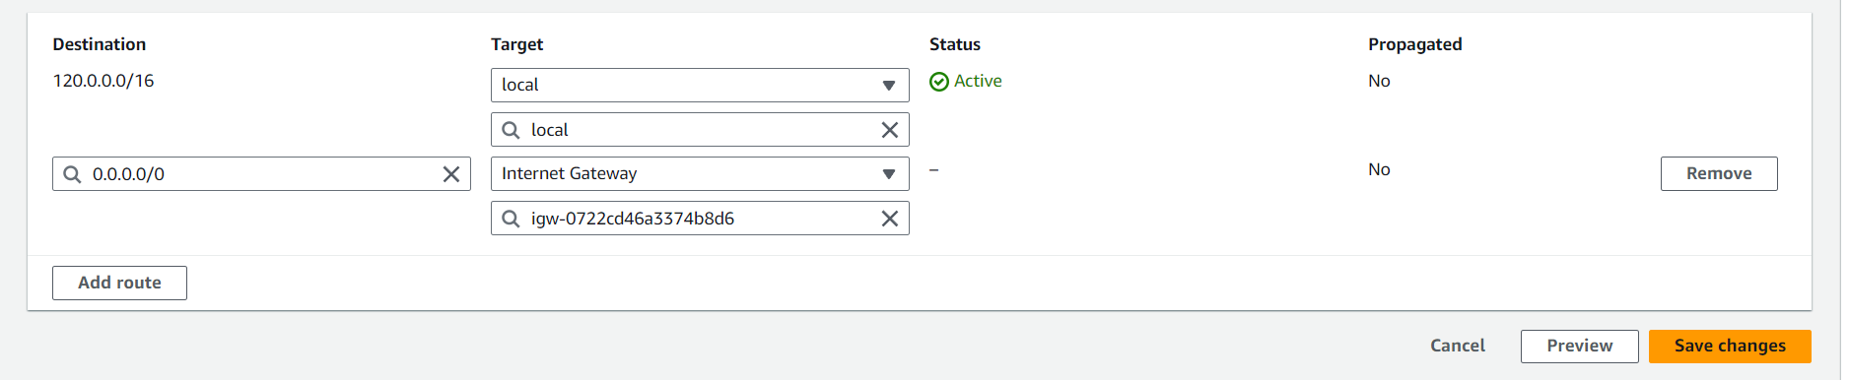

* **Step 7**: Under the **Subnets associations** tab, click **Edit subnet associations** 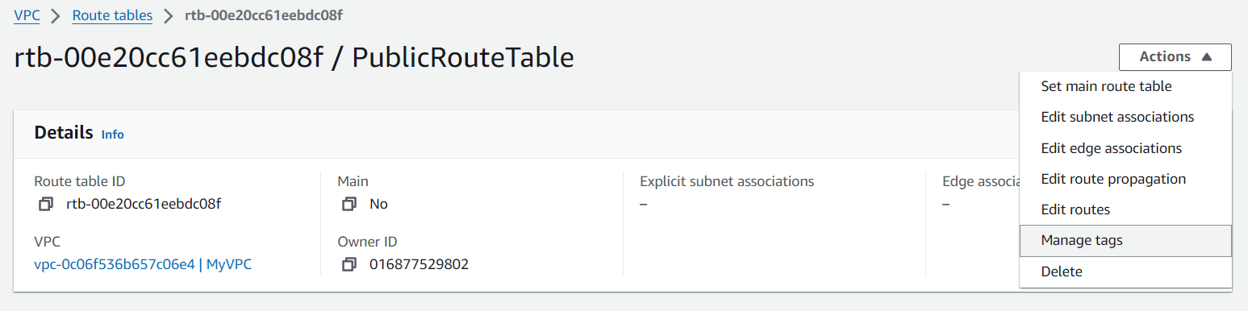
* and select your public subnet.

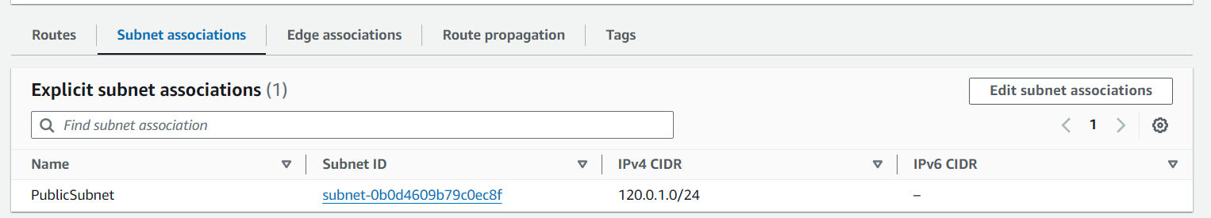

**5. Create a NAT Gateway**

* **Step 1**: In the VPC Dashboard, click on **NAT Gateways** in the left navigation pane, then click **Create NAT gateway**.

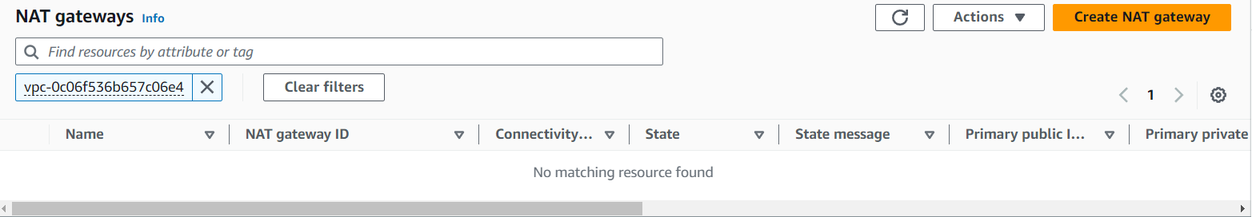

* **Step 2**: Enter the following details:
  + **Name tag**: (e.g., MyNATGateway)
  + **Subnet**: Select your public subnet.
  + **Elastic IP allocation ID**: Allocate a new Elastic IP or select an existing one.
* **Step 3**: Click **Create NAT gateway**.

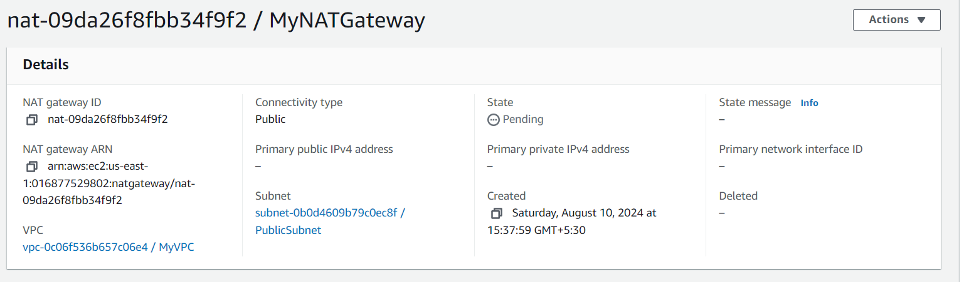

**6. Create a Route Table for the Private Subnets**

* **Step 1**: In the VPC Dashboard, click on **Route Tables** in the left navigation pane, then click **Create route table**.
* **Step 2**: Select the VPC you created, and enter a name tag (e.g., PrivateRouteTable).
* **Step 3**: Click **Create route table**.
* **Step 4**: Select the newly created route table, and under the **Routes** tab, click **Edit routes**.
* **Step 5**: Click **Add route**:
  + **Destination**: 0.0.0.0/0
  + **Target**: Select your NAT Gateway.
* **Step 6**: Click **Save changes**.

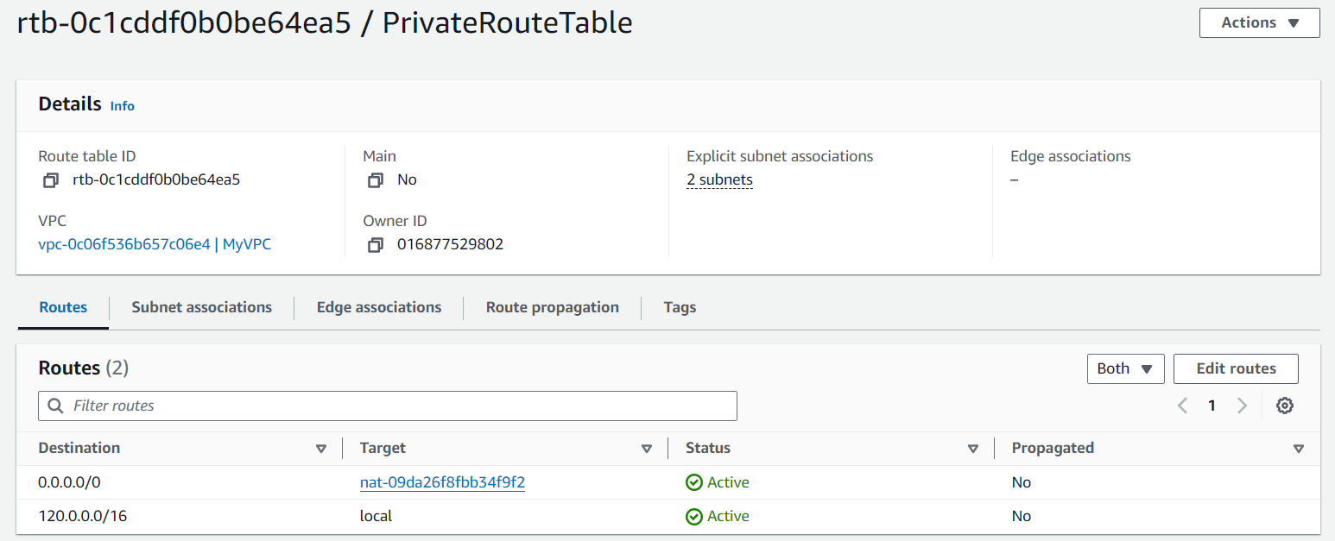

* **Step 7**: Under the **Subnets associations** tab, click **Edit subnet associations** and select your private subnets.

